Compiler Design Practical File
Name- Prateek Ramchandani
Roll No.- 22078570042

Q1. Write a LEX program to count the number of lines and characters in the input file.

Code:

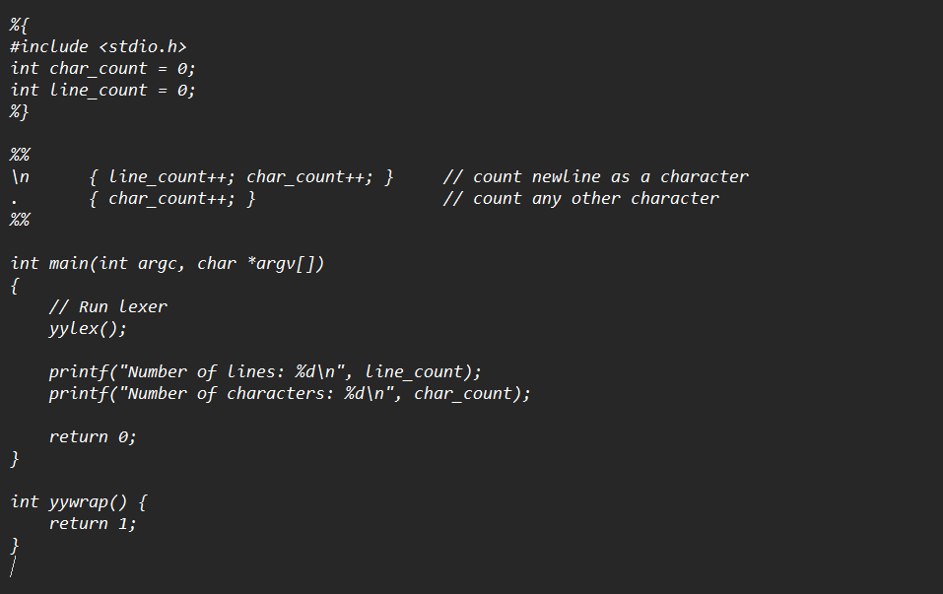

Output:

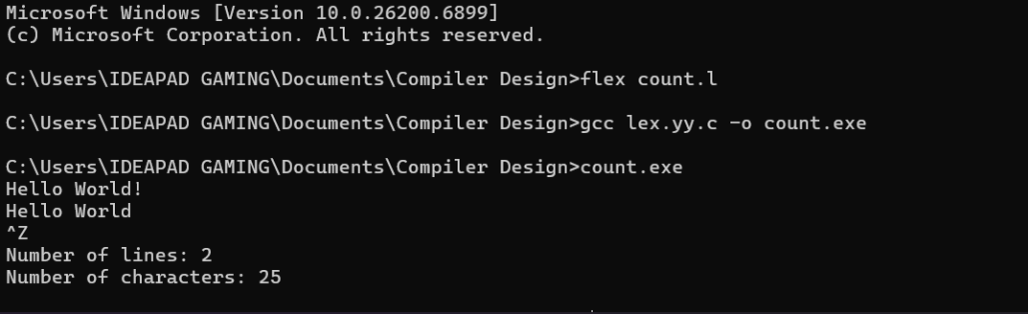

Q2. Write a Lex Program to count the number of vowels and consonants in a given string.

Code:
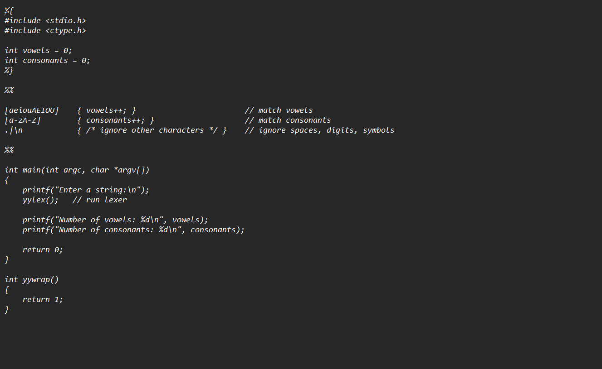

Output:
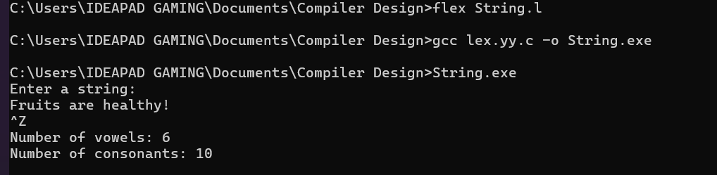

Q3. Write a Lex Program that finds the longest word (defined as a contiguous string of upper and lower case letters) in the input.

Code:

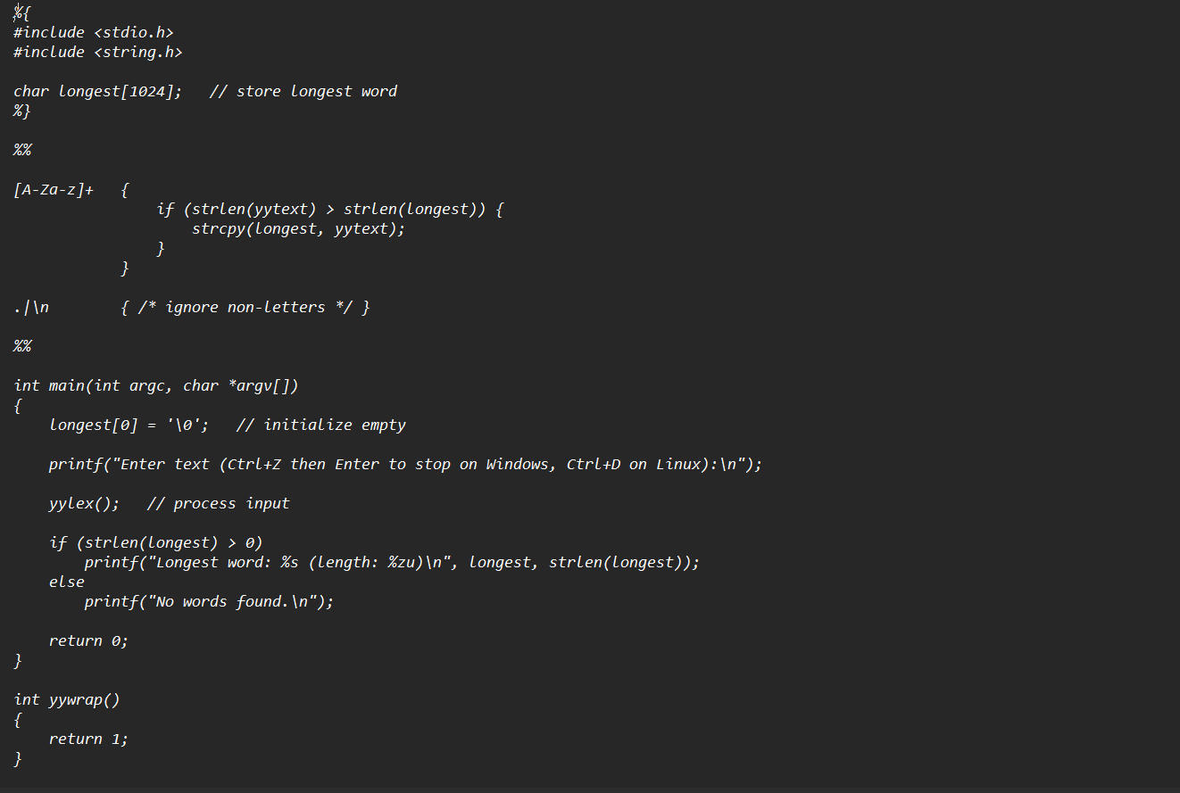
Output:

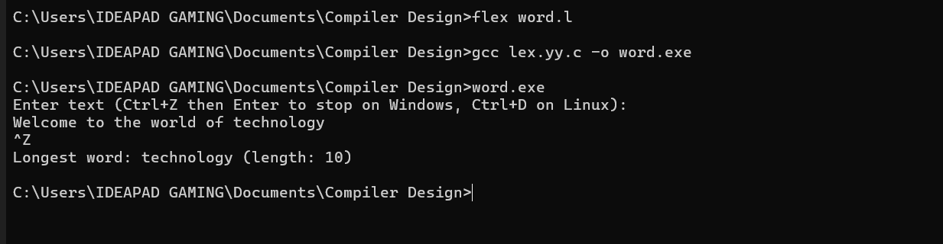

Q4. Write a Lex Program that implements the Ceaser cipher.

Code:

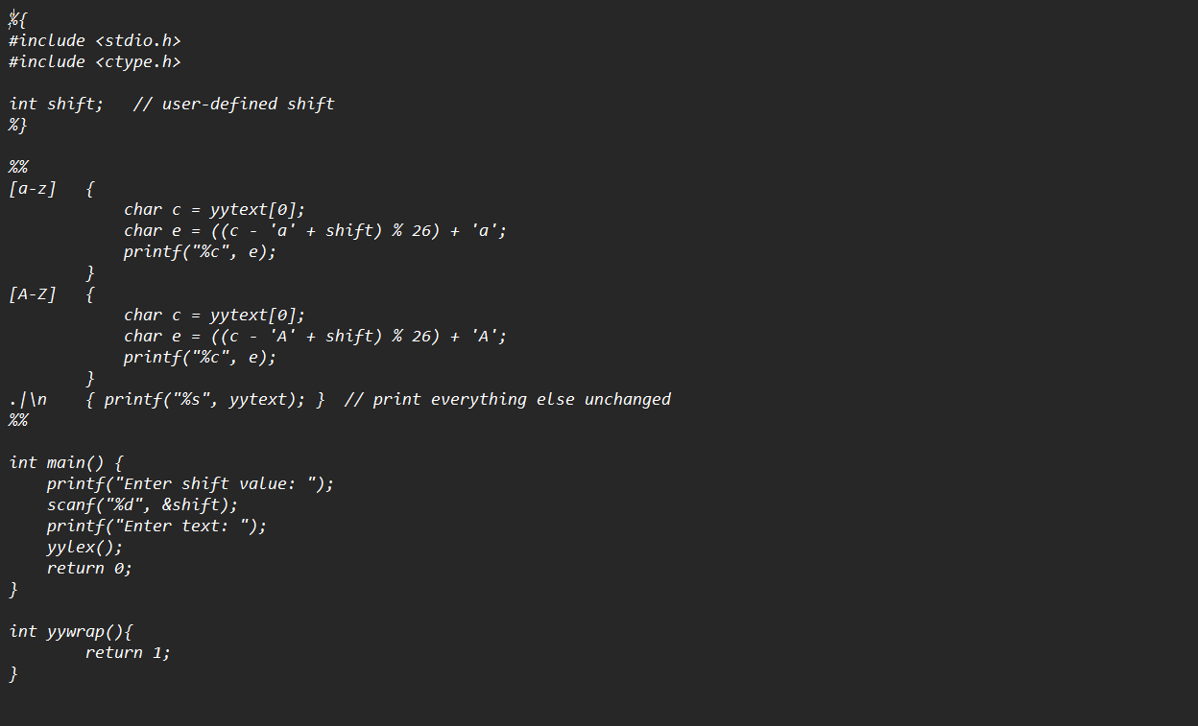

Output:

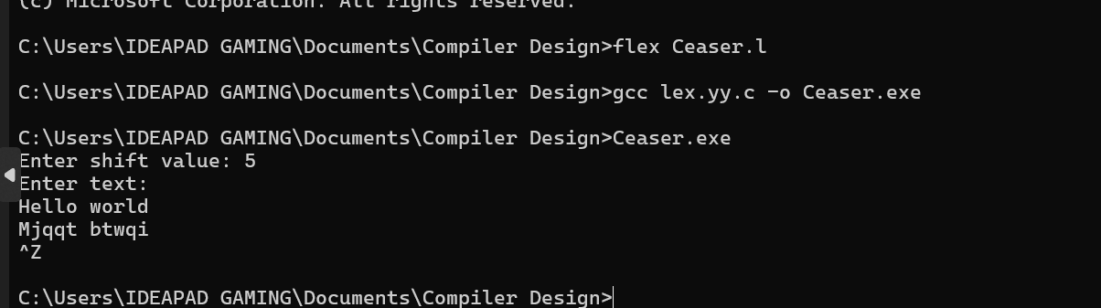
Q5. Write a Lex program that distinguishes keywords, integers, floats, identifiers, operators and comments in any simple programming language.

Code:
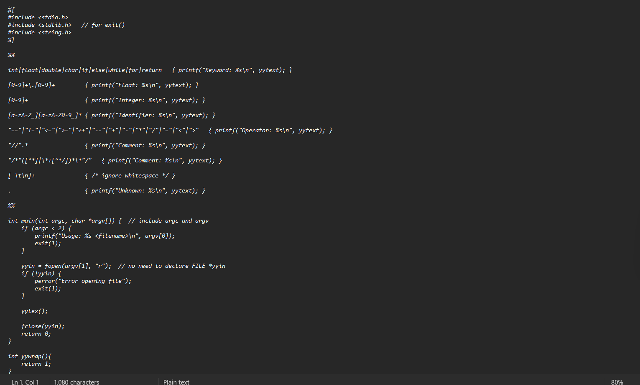

Output:
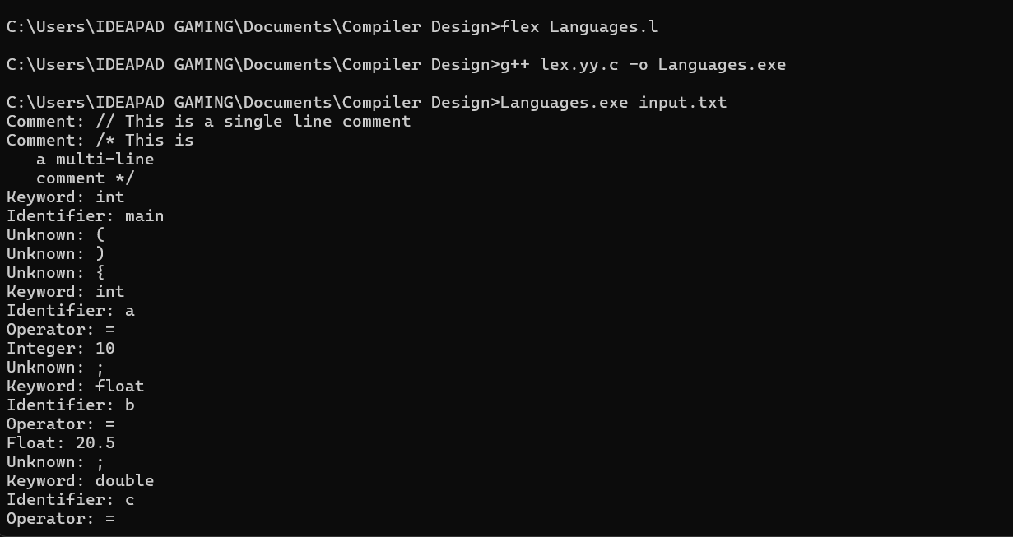

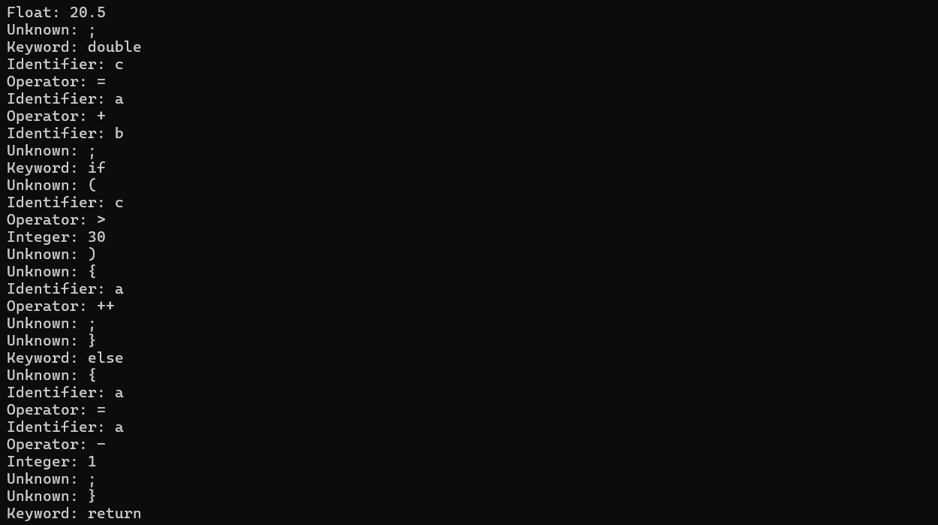
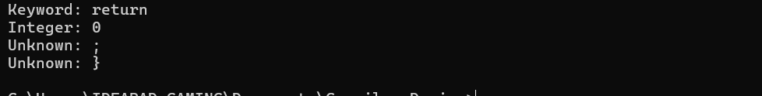
Q6. Write a Lex program to recognize valid arithmetic expression.
Code:

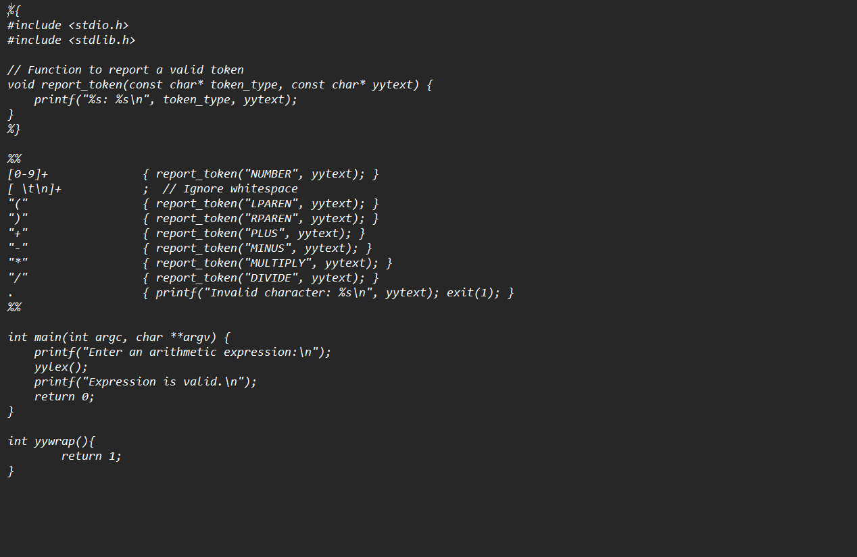
Output:
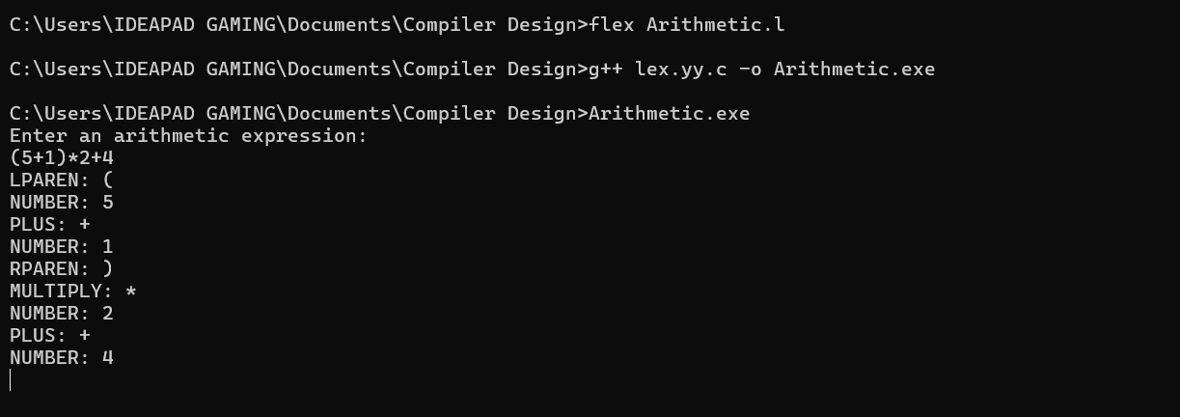
Q7. Write a Lex Program to count the number of words, characters, blank spaces and lines in c file.

Code:

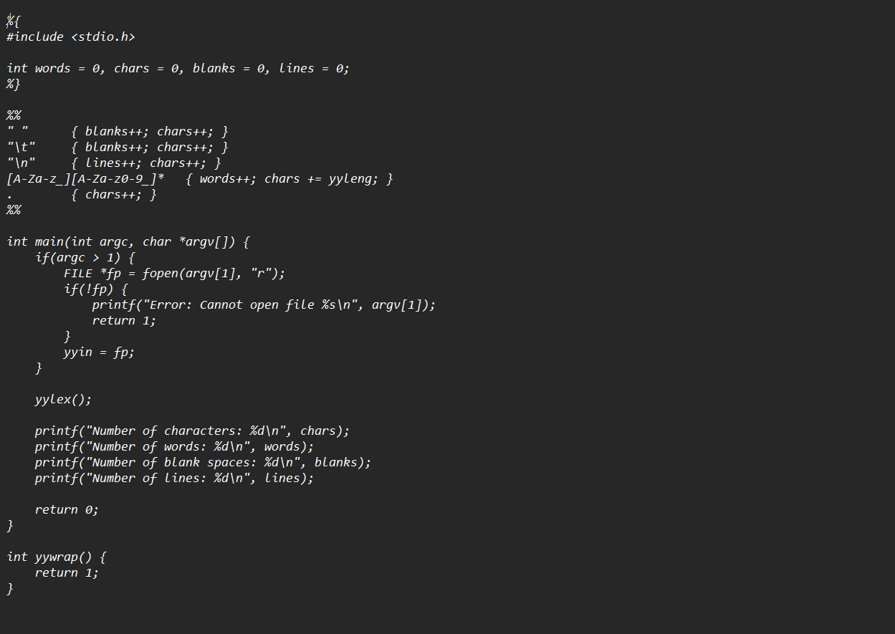

Output:
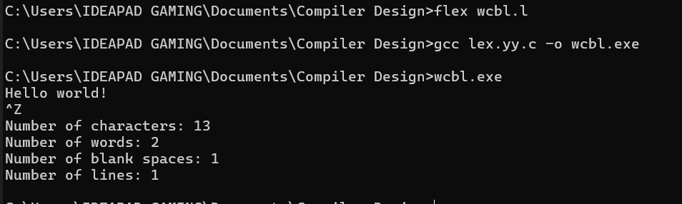
Q8. Write a Lex specification program that generates a c program which takes a string abcd and prints the following - abcd -abc -ab -a.

Code:
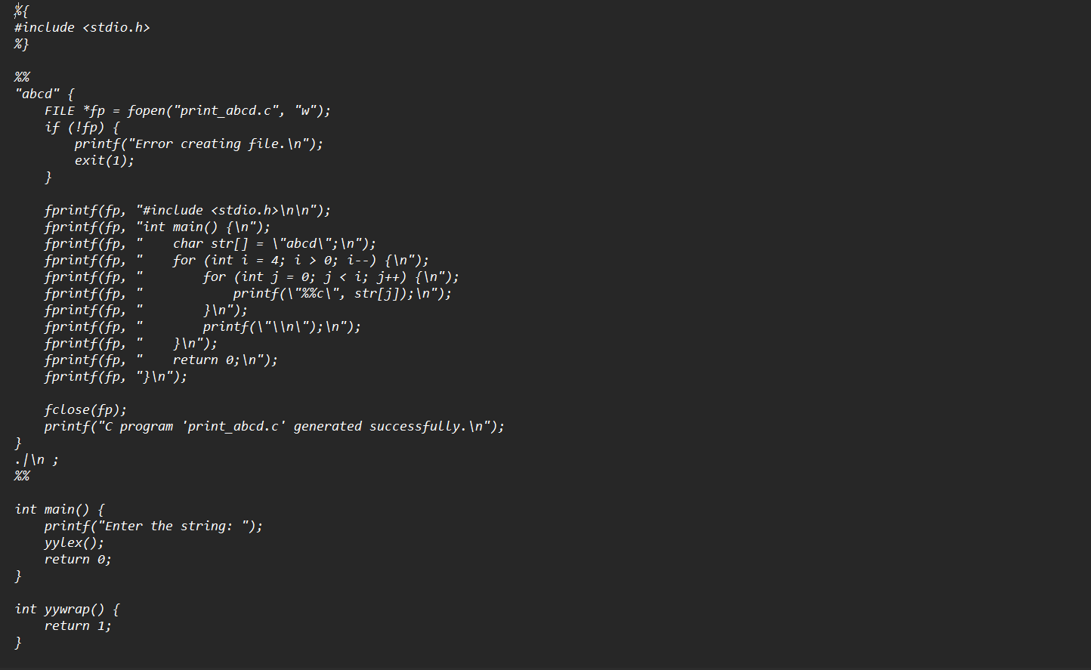

Output:
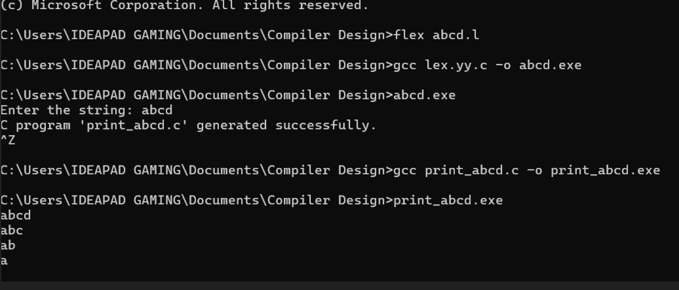

Q9. Write a YACC program to find the validity of a given expression (for operators + -
* and /) A program in YACC which recognizes a valid variable which starts with
letter followed by a digit. The letter should be in lowercase only.

Code:
(Part 1)
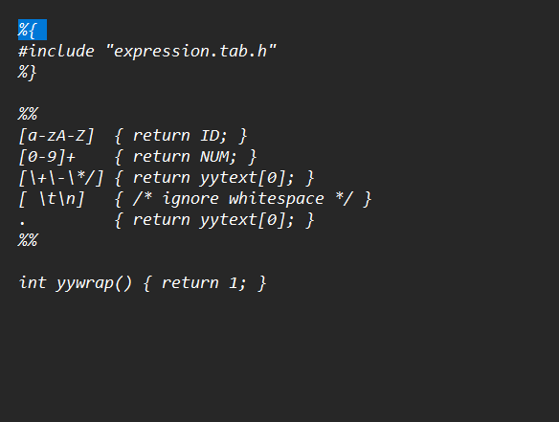

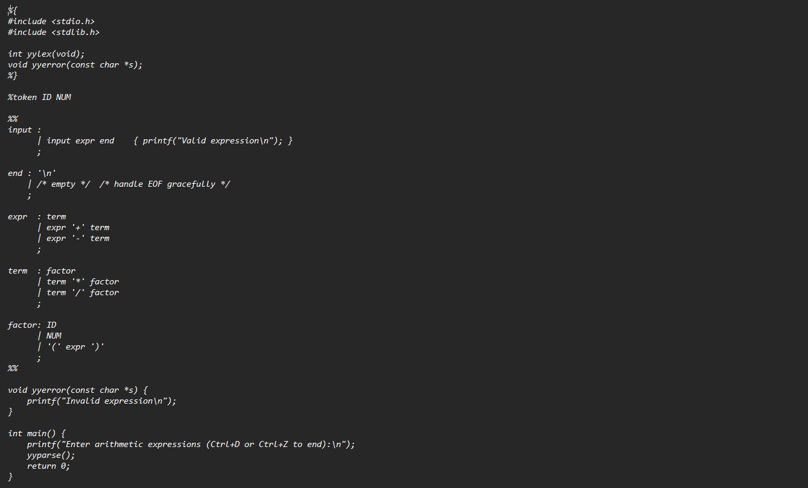

Output:
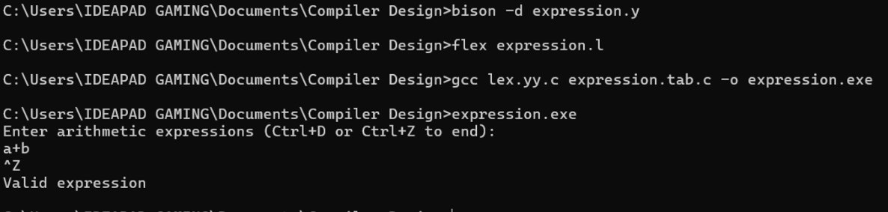

Part 2:

Code:

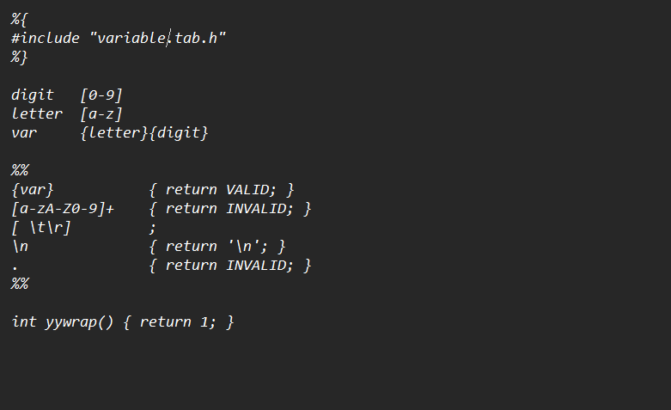

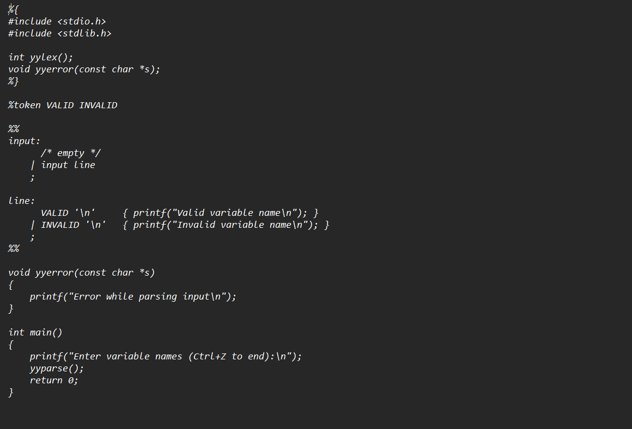

Output:
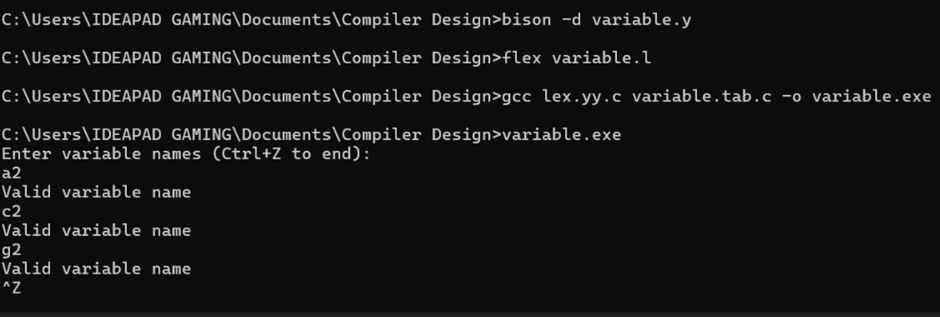
Q10. A Program in YACC to evaluate an expression (simple calculator program for
addition and subtraction. multiplication. division).

Code:
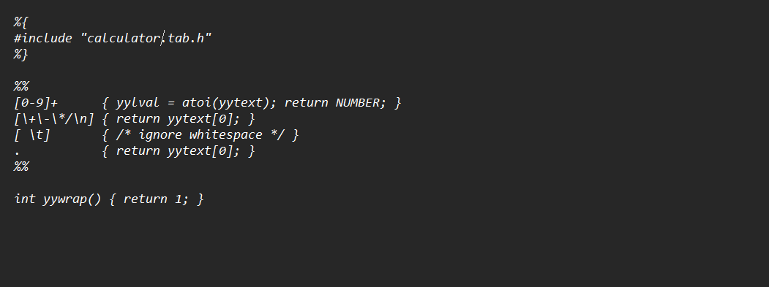

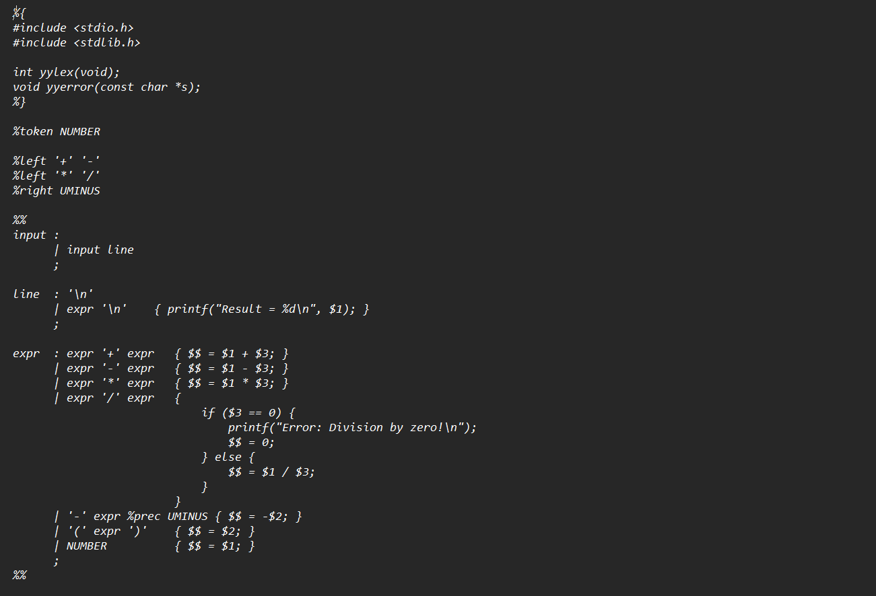
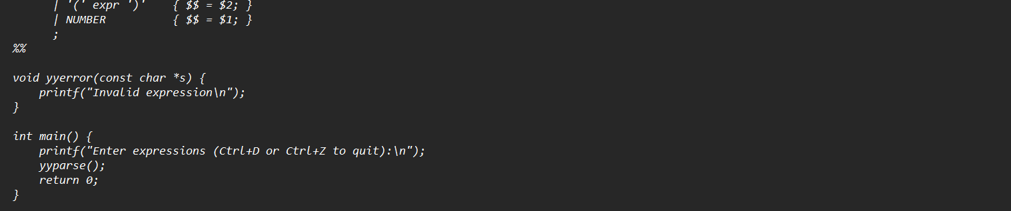

Output:

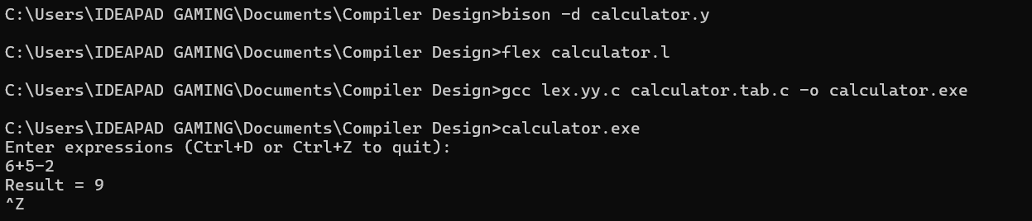

Q11. Program in YACC to recognize the string ,,abbb”, ,,ab”, ,,a” of the language (anbn , n >= 1).

Code:
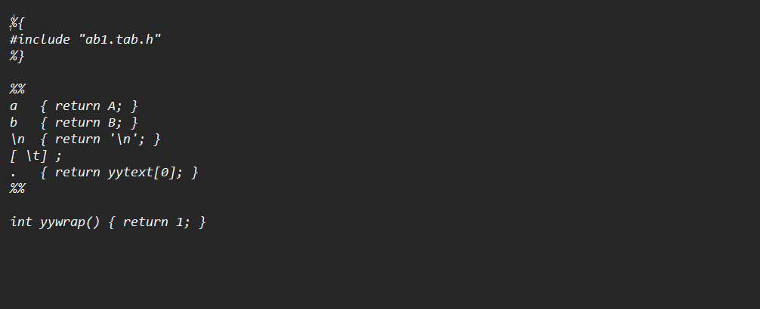

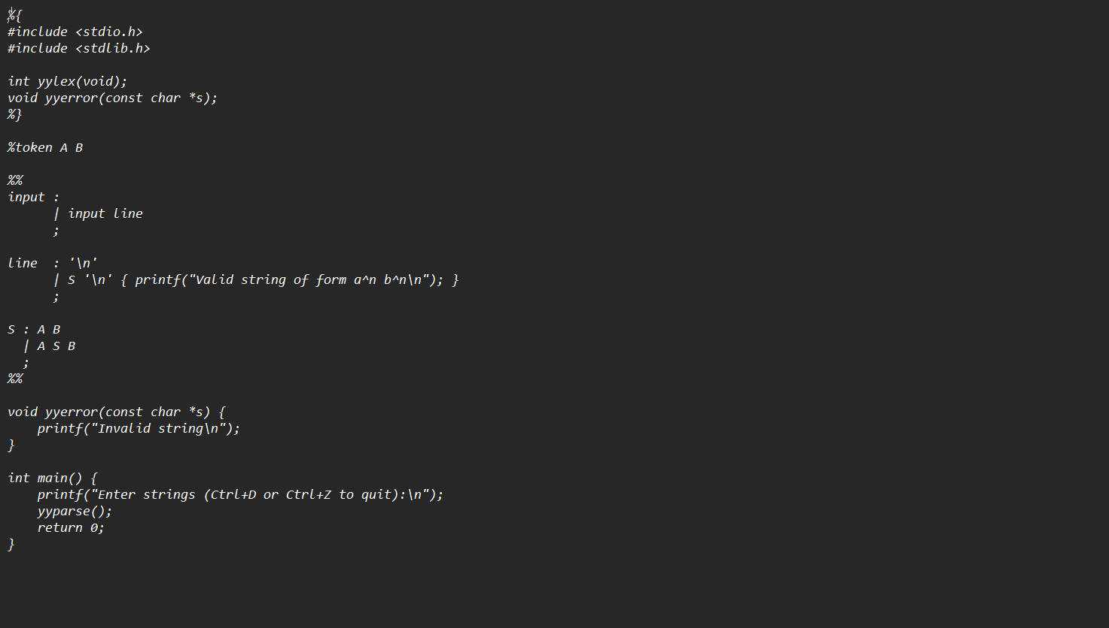

Output:
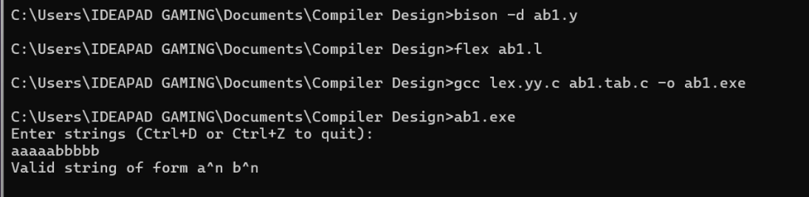

Q12. Program in YACC to recognize the language (anbn , n>=10). (output to say input
is valid or not).

Code:
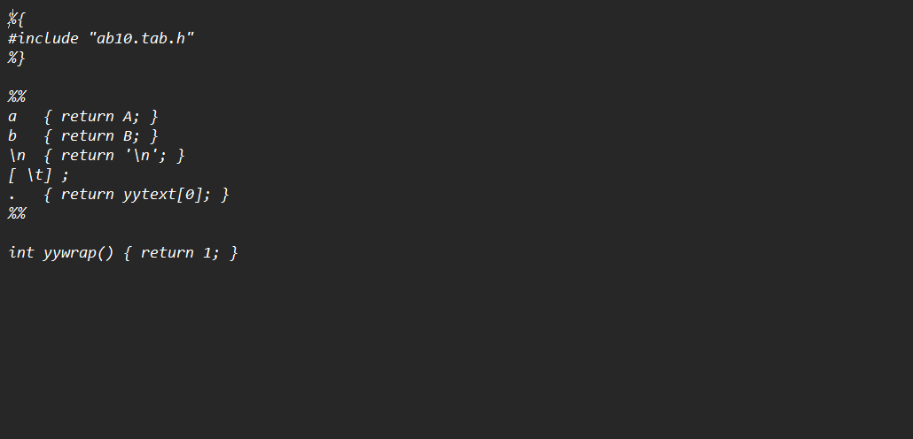

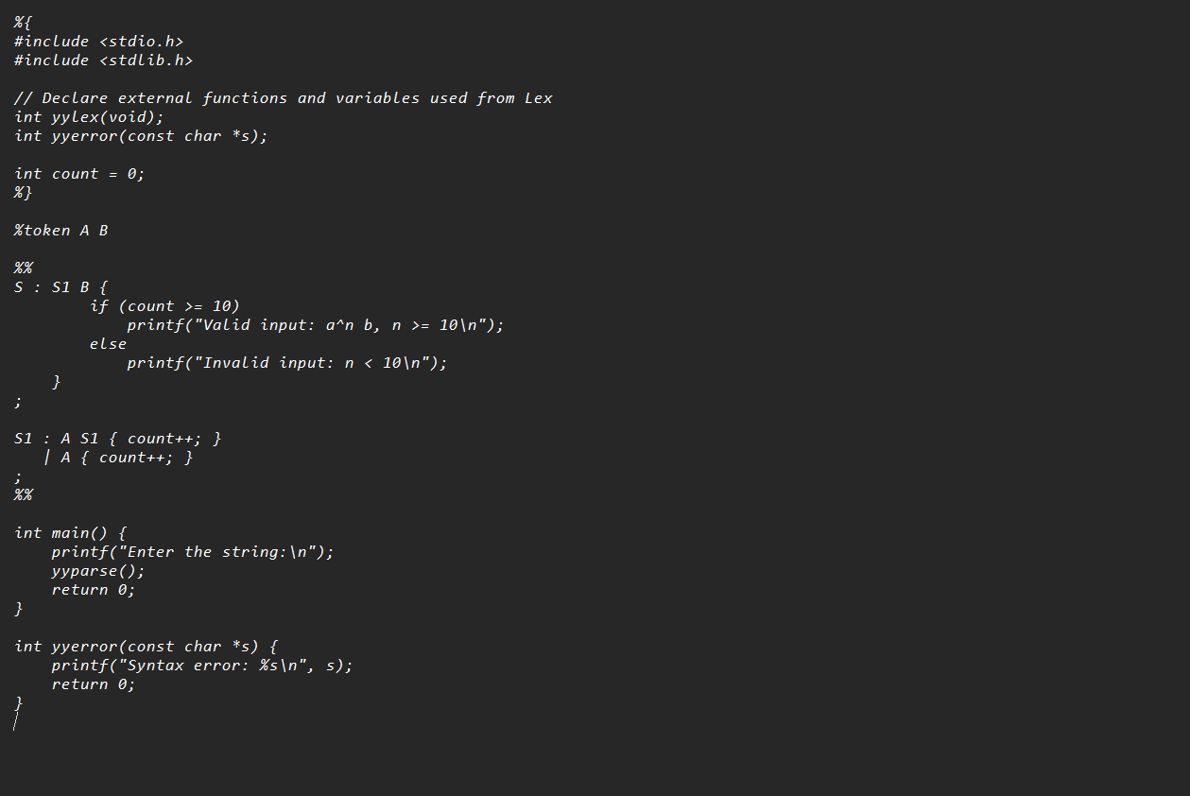

Output:
